**Stat 301 Lab 3**

# Overview

Use commands in the JMP Analyze / Distribution menu for inference (hypothesis test, confidence interval) on a single mean.

Use a journal to save results and export them to Word

# Lab Activities

We will continue the analysis of the COD data presented in class. That file is COD.txt on the class web site, <http://www.public.iastate.edu/~pdixon/stat301/>

Load the datafile into JMP (see Lab 2 if you don’t remember how).

The Recent Files scroll-down list provides rapid access to data sets you’ve used recently.

1) To test H0: μ = 32.5:

1. Start with Analyze / Distribution, and specify COD as the response (Y) variable. This provides various results, but not a test of a specific mean. That is available as an additional piece of output (so think about looking for it under red triangle).

1. Click the red triangle by the name of Y, i.e. by COD. You should see the following drop-down menu:

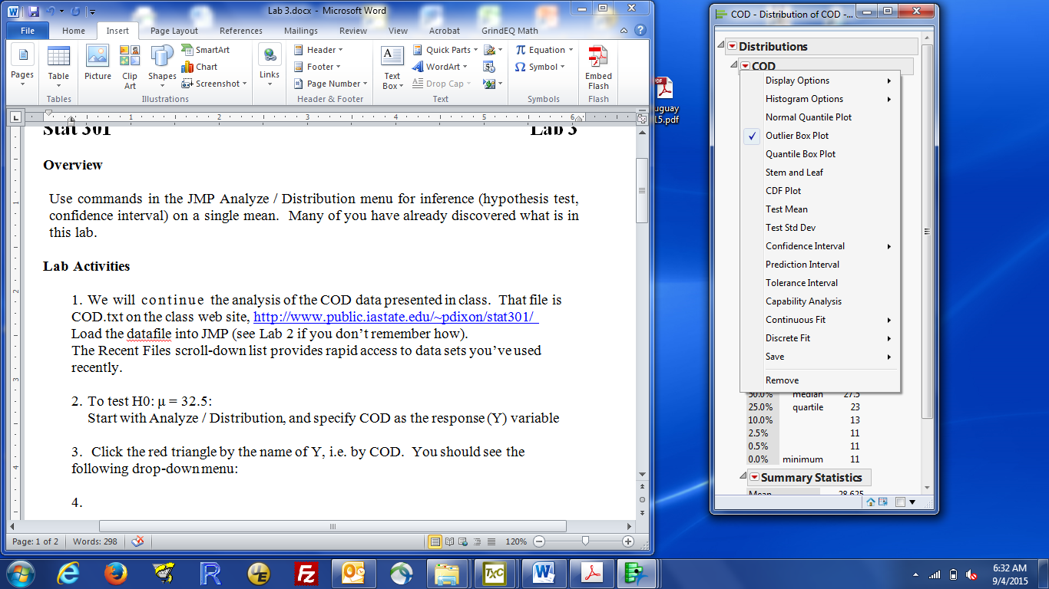

1. Click Test Mean, specify the hypothesized mean (e.g. 32.5), leave the other boxes blank (you want to estimate the sd from the data) and click OK
2. A box with Test Mean output is appended to the Analyze / Distribution results window. You should see (upper contents of window omitted)

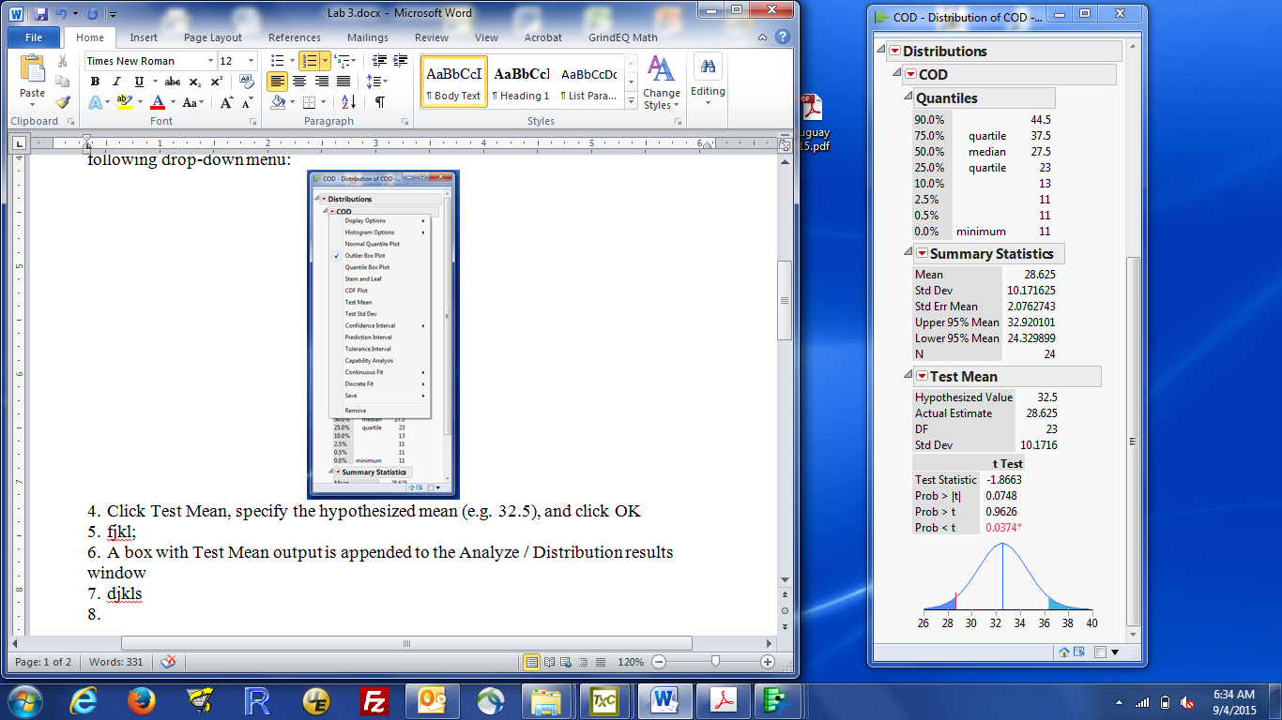

1. The two-sided p-value is the value labelled: Prob > |t|, i.e. 0.0748, which I suggest you report as 0.075.

NOTE: The hardest thing with the JMP t-tests is figuring out which p-value you want. The two labelled Prob > t and Prob < t are p-values for the two one-sided hypotheses (μ > 32.5 and μ < 32.5).

We will follow scientific convention and exclusively use two-tailed p-values. That means you want Prob > |t|.

1. The smoothed histogram at the bottom of the output shows the sampling distribution of the average when H0 is true (centered at 32.5, the H0 μ). The observed sample average is the red bar and the two-tail probabilities (more extreme results) are shaded in blue. The two-sided p-value is the sum of the blue areas.

2) To get a confidence interval for the estimated mean: a 95% CI is reported by default in the Summary Statistics box, labeled as Upper 95% Mean and Lower 95% Mean. The 95% confidence interval for the mean is (24.3, 32.9)

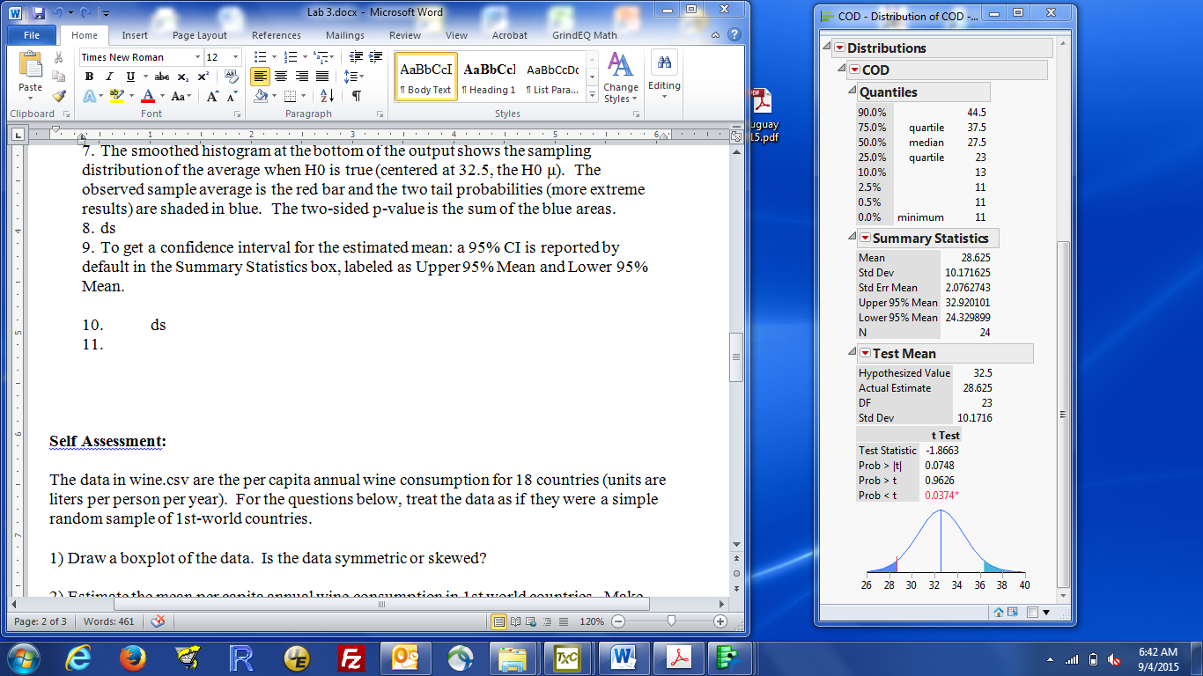

To change the confidence level (e.g. from 95% to 90%, or 99%), either:

1. click the red triangle by COD, select Confidence Intervals. You get offered the choices of 90%, 95% and 99% or other, if you want something less common. Select the appropriate choice. Results are appended to the Analyze / Distribution window:

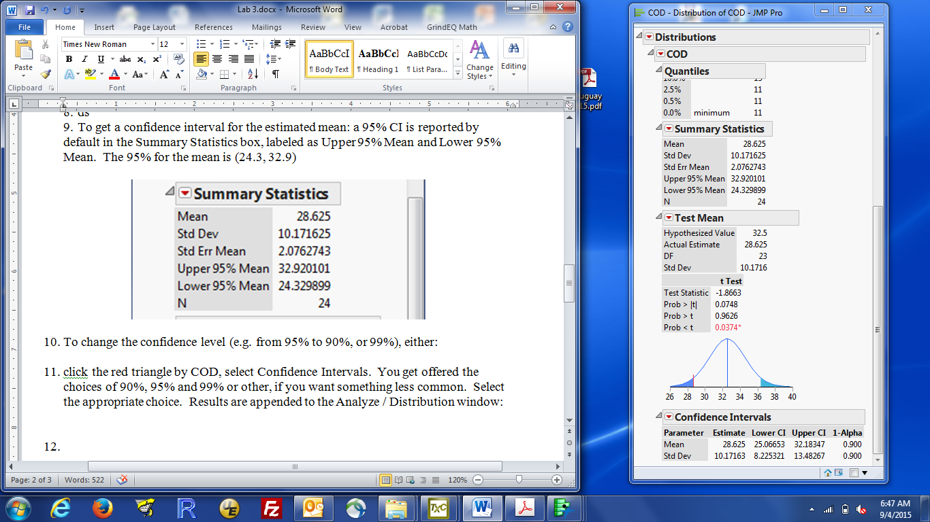

The numbers you want are those in Mean row. The Lower CI, Upper CI in the Mean row are the endpoints of the confidence interval for the mean. The coverage is in the 1-alpha column. This box tells you that 90% CI for the population mean is (25.1, 32.2).

(It is possible to get a confidence interval for any statistic. So, JMP can calculate the confidence interval for the standard deviation. We don’t talk about how to do that in this class).

1. OR: click the red triangle by Summary Statistics, select Customize Summary Statistics, and enter the desired confidence level (e.g., 0.90) in the box almost at the bottom of the window:

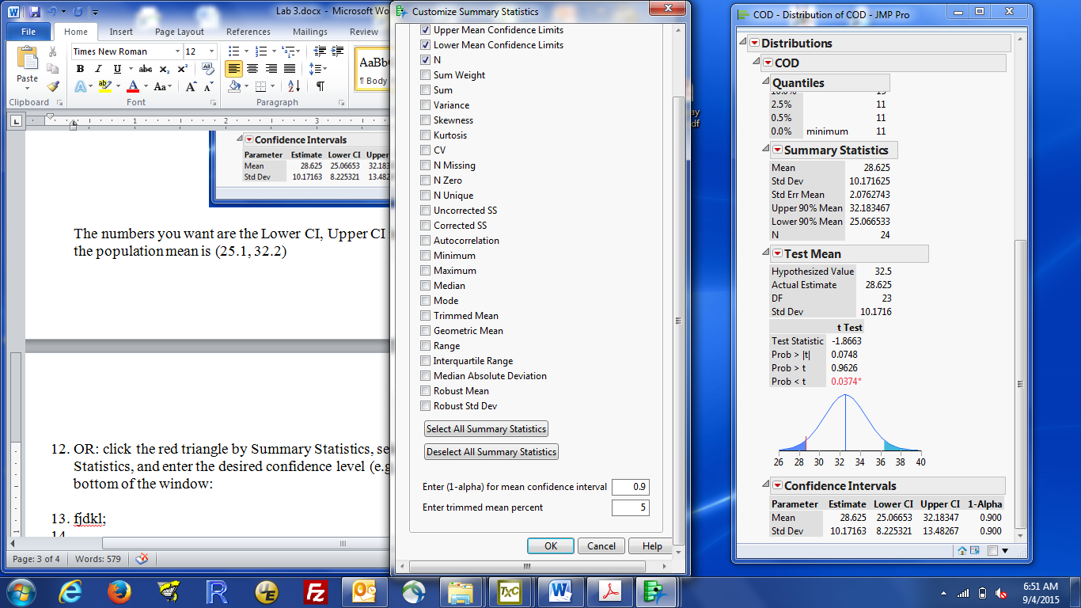

Click OK and the interval shown in the Summary Statistics box changes to the specified coverage.

3) The JMP journal provides a mechanism to save any results, both graphs and tables. Last week, we saw how to copy a graph to paste into Word. The journal is an alternative that some find easier to use. The journal is stored in a JMP-readable format, but it can be exported to a Word document. You can then add verbiage around the JMP results or copy from the JMP Word document to another document (e.g. with your HW answers).

a) To save the entire Analyze/Distribution output for the COD values:

Find the hidden menu (light blue bar at the top of the output on a windows PC), hover over it (turns darker blue, click it if necessary and a menu appears), then select edit / journal. Journal is near the very bottom of the menu). The menu is on the right, below.

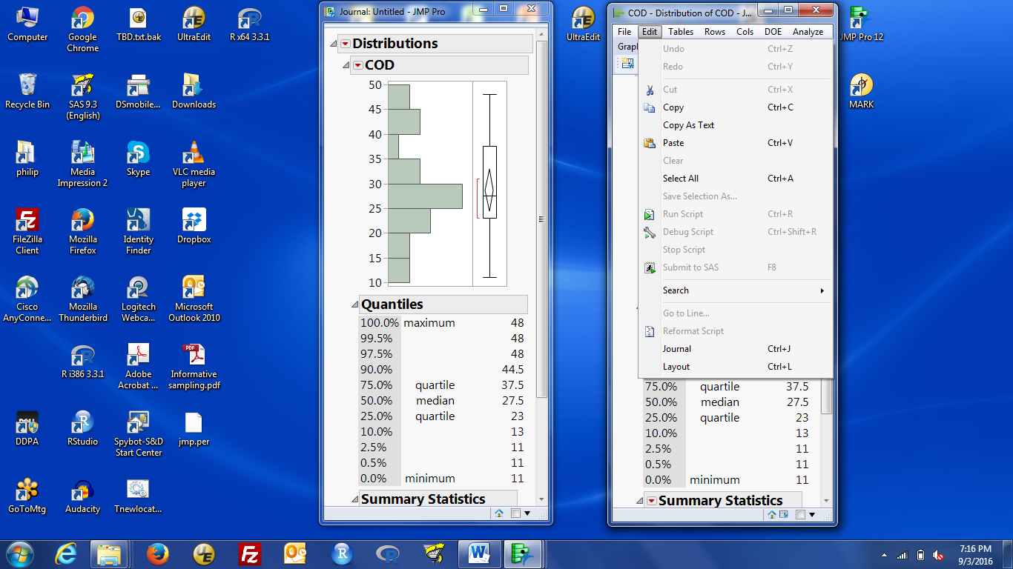

When you click journal, a new window labelled Journal Untitled will appear. This contains all the material that is saved in the journal. The red triangles in the journal still bring up menus, but there are no analysis options. You can rerun an analysis to recreate the original analysis, which then gives you access to analysis options.

The hotkey to save a window to the journal is control-j.

Using edit / journal or control-j on a window saves the entire window to the journal.

b) The same process works for a graph. The graph is the entire window, except for the lower-quality graphs that are part of a larger set of results.

c) To save just one table to the journal, you need to select the table, then journal it:

Find the hidden menu (light blue bar at the top of the output on a windows PC), hover over it (turns darker blue, click it if necessary and a menu appears). Below the usual Window-like words are some symbols:

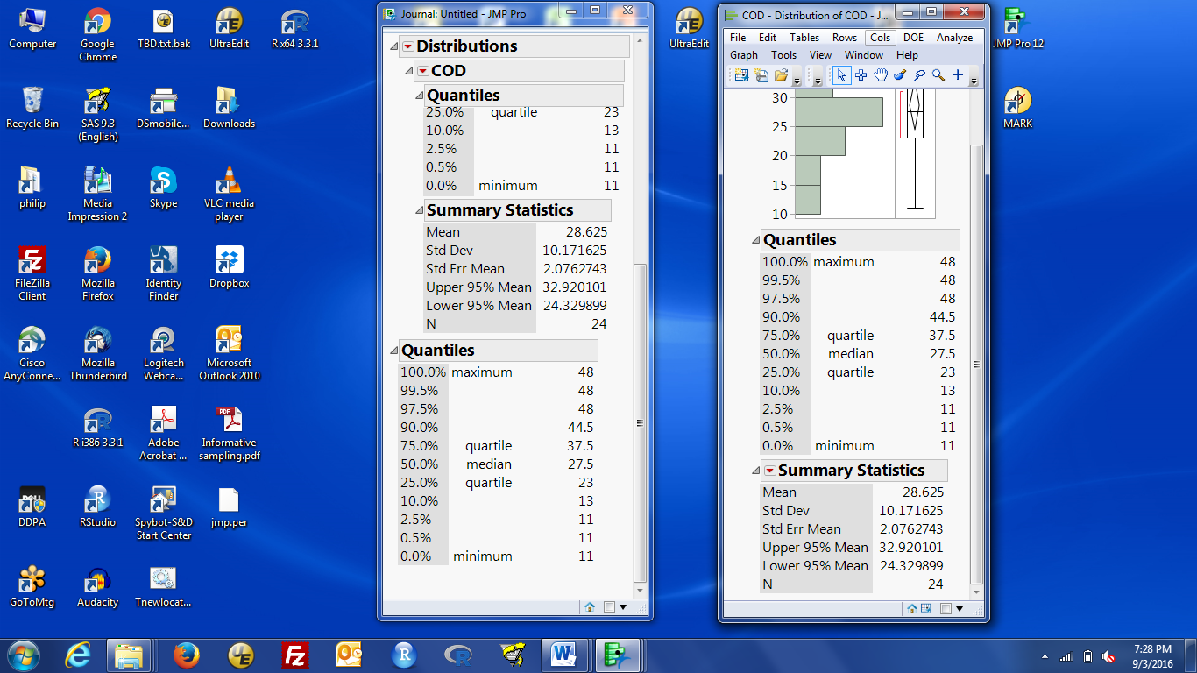\

The ones on the right-hand side control what the mouse does. The default selection is the pointer (arrow). The fat + sign (circled in red here) is the “Select” behaviour. Click on that. Now, when you left-click on something, that part of the output can be copied to the clipboard (edit/copy or control-c) or journaled (edit/journal or control-j).

d) Clicking on the header label selects the entire table. So clicking on “Summary Statistics” highlights the table of summary statistics. control-j will then copy that table to the journal. (There already was one there because you previously journaled the whole window. Now you have a second copy).

e) Clicking on a column selects just that column. If that’s not what you want, reselect what you want.

f) New material is added to the bottom of the journal, so the journal provides a single place to keep all the results you really want.

g) The journal can be saved as a stand-alone file or exported to another file format. To export the journal:

Click on the top of the journal window to make it active, activate the hidden menu (light blue bar), select file / save as.

This let you save the journal in various formats. Word 2000 (.doc) is at the bottom. Tables are saved as word tables; graphs are saved as word figures.

h) If you only get the option to save as a journal (.jrn) file, you selected file / save, not file / save as.

**Self Assessment:**

We continue with the data in wine.csv used last week. These are the per capita annual wine consumption for 18 countries (units are liters per person per year). For the questions below, treat the data as if they were a simple random sample of 1st-world countries, and use the T-statistic based methods discussed in class and this lab.

1) Test the hypothesis that the population mean is 10 litres/person/yr. Report the p-value and a one-sentence conclusion, using the scale of evidence given in lecture

**Answers:**

1) p = 0.25, no evidence that the mean consumption differs from 10 l/p/yr